Number of Vowels
AIM:
To write a Prolog program to count the number of vowels in a given string.
ALGORITHMS:
- Start.
- Accept a string or list of characters as input.
- Initialize the vowel counter to zero.
- Check each character in the input.
- If the character is a vowel (a, e, i, o, or u), increment the counter.
- Otherwise, keep the counter unchanged.
- Repeat Steps 4–6 until all characters have been checked.
- Display the total number of vowels.
- Stop.

CODE:
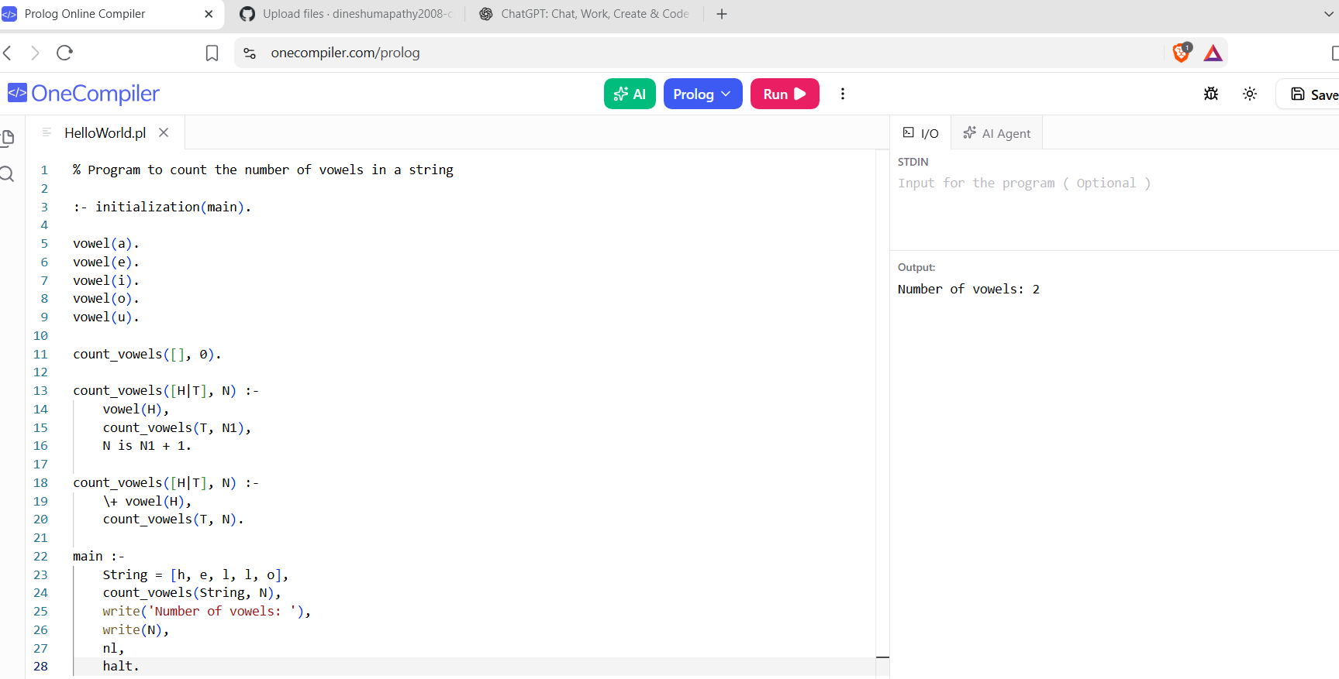
RESULTS:
The program counts and displays the total number of vowels present in the given string.

